Script for 5 minutes Prezi Video

Greetings to all of the judges and panellists.

We are team _____

(Ideation on this project ) by Jasper 250 words ()

In this digital era, we are using various digital apps in our daily life, such as FoodPanda for ordering takeaway, Uber for ordering taxi and various online shops for daily shopping, these platforms bring convenience to our life, but also lots of chances to spend money on goods or services that we do not need which does not only burns our saving, but also causing various of problems such as landfill overload, increase transportation and logistic cost.

One of the solutions to this problem is to increase awareness of spending. But HOW ?

We are aware that most of these spendings on digital app generate e-receipts which send to our mailbox. These e-receipts are mostly ignored or send to junk boxes right away, so customers like us did not aware what did we purchase until the credit card bill came and shocked us.

We decided to do something about it, to make people take a “second look” on their e-receipt, to make them aware where did they spend their money. What if we turn the e-receipt into something that can be tradable , a digital asset, by just few clicks ? In that case, customer will spend some time and take a “second look” on their receipt.

As such, our team have developed a solution to turn these e-receipt into digital asset with Web3 integration.

(Idea explanation and current progress) by Brian 250 words ()

Our solution allows user to upload their e-receipt to our platform , our system will transform these into NFT token protected by blockchain technology which the users will receive tokens for uploading to our platform.

Here is how this works, user will upload their receipt to our portal. Our portal will cross-check if this is a valid receipt. If confirmed, it will transfer to a converter which convert the jpeg into NFT file storage. The user who uploaded the data will receive a token as rewards.

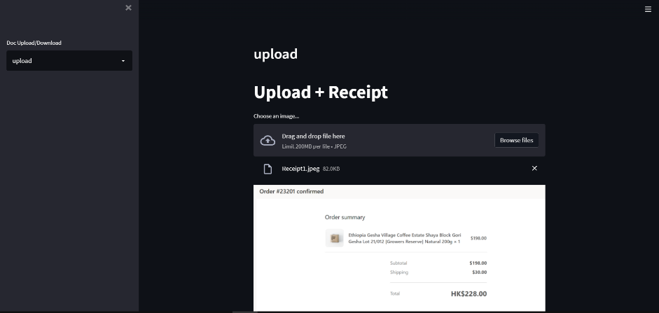

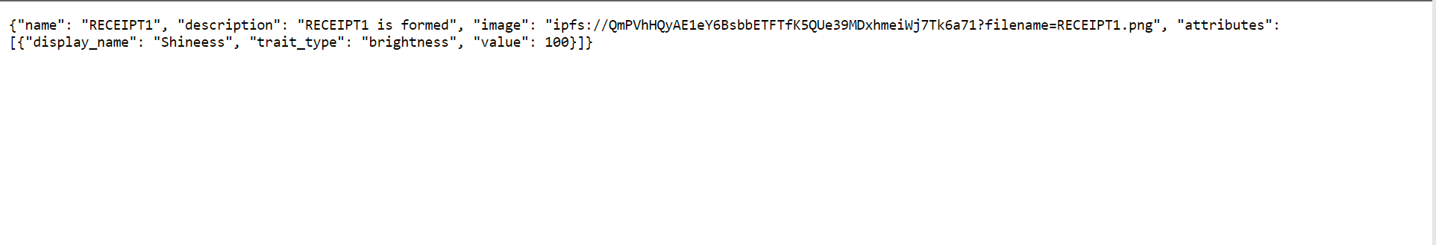

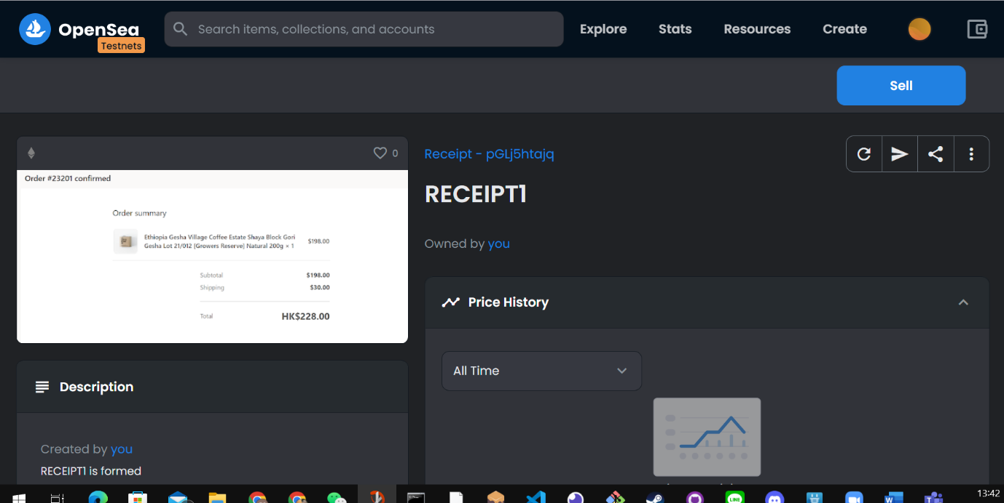

We are currently developed the backend for NFT generation and successfully deployed on Opensea testnet platform as a proof-of-concept. Our team will continue develop the frontend and program interface for more coinvent user For the detailed code, please feel free to go to our github page

(Practicality and business model) 200 words ()

This project does not only let our user increase their awareness on their spending , but also provide another portal for e-commerce platforms to acquire user behaviour on the market according to geographic location. This can help e-commerce merchants to better capture the market trend and generate more sales revenue.

The main cashflow to fund the development of this project would be the fee provided by e-commerce platforms and online merchant , plus the token provided from Chainlink. The Full development will be split into 3 phases.

On the Phase 1 of this project, we will launch a prototype with “receipt upload” and ”NFT transform” function on web app format, which we will start to collaborate with major e-commerce platforms to invite their users to test our app.

On the Phase 2 of this project , we will launch the “receipt check” function which verify if the receipt upload is a genuine copy from merchant or a forged one based on the format of e-receipt of the e-commerce platforms and other merchants.

On the phase 3 of this project, we will launch an phone app which allows user to upload their receipt via mobile app and receive token on their mobile wallets, which we will start to provide adequate updates for the user and bringing new functions for our users.

This is the end of our presentation. Thank you for your time and Have a good day.